Lab 6
Web programming

Name : umar ahad uddin ahmed usmani
Sap : 60199

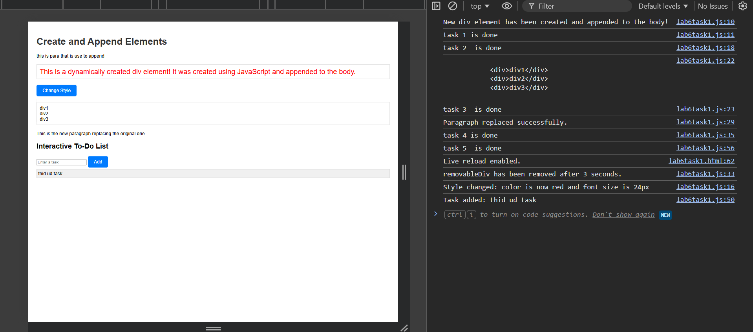

<!DOCTYPE html>
<html lang="en">
<head>
<meta charset="UTF-8">
<meta name="viewport" content="width=device-width, initial-scale=1.0">
<title> Create and Append Elements</title>
<link rel="stylesheet" href="lab6task1.css">
</head>
<body>
<h1>Create and Append Elements</h1>
<p>this is para that is use to append</p>

<button id="changeStyleBtn">Change Style</button>

<div class = "parent">
<div>div1</div>
<div>div2</div>
<div>div3</div>
</div>

<p id="originalPara">This is the original paragraph that will be replaced.</p>
<div id="removableDiv">This div will be removed after 3 seconds.</div>

<h2>Interactive To-Do List</h2>
<input type="text" id="todoInput" placeholder="Enter a task">
<button id="addBtn">Add</button>
<div id="todoList"></div>

<script src="lab6task1.js"></script>
</body>
</html>

const newDiv = document.createElement('div');

newDiv.textContent = 'This is a dynamically created div element! It was created using JavaScript and appended to the body.';

newDiv.id = 'dynamicDiv';

document.querySelector("p").appendChild(newDiv);

console.log('New div element has been created and appended to the body!');
console.log("task 1 is done");
const changeStyleBtn = document.getElementById('changeStyleBtn');
changeStyleBtn.addEventListener('click', function() {
newDiv.style.color = 'red';
newDiv.style.fontSize = '24px';
console.log('Style changed: color is now red and font size is 24px');
});
console.log("task 2 is done");

const parents = document.querySelector(".parent");
console.log(parents.innerHTML);
console.log("task 3 is done");

const originalPara = document.getElementById('originalPara');
const newPara = document.createElement('p');
newPara.textContent = 'This is the new paragraph replacing the original one.';
originalPara.replaceWith(newPara);
console.log('Paragraph replaced successfully.');
const removableDiv = document.getElementById('removableDiv');
setTimeout(() => {
removableDiv.remove();
console.log('removableDiv has been removed after 3 seconds.');
}, 3000);
console.log("task 4 is done");

const addBtn = document.getElementById('addBtn');
const todoInput = document.getElementById('todoInput');
const todoList = document.getElementById('todoList');

addBtn.addEventListener('click', function() {
const taskText = todoInput.value.trim();

if (taskText !== '') {
const taskItem = document.createElement('div');
taskItem.textContent = taskText;
taskItem.className = 'todo-item';
todoList.appendChild(taskItem);
console.log(`Task added: ${taskText}`);
todoInput.value = '';
} else {
console.log('Input is empty. No task added.');
}
});
console.log("task 5 is done");

body {
font-family: Arial, sans-serif;
padding: 20px;
}

h1 {
color: #333;
}

#dynamicDiv {
margin: 20px 0;
padding: 10px;
border: 1px solid #ccc;
}
.parent{
margin: 20px 0;
padding: 10px;
border: 1px solid #ccc;

}

button {
padding: 10px 20px;
font-size: 16px;
cursor: pointer;
background-color: #007bff;
color: white;
border: none;
border-radius: 5px;
}

button:hover {
background-color: #0056b3;
}
.todo-item {
padding: 5px;
margin: 5px 0;
background-color: #f0f0f0;
border: 1px solid #ccc;
}

